The Faithful Speaking of God’s Word  Promise: the Word of God wounds in order to heal  Pastor Timothy A. Duesenberg  Jer 23:16-29; Ps 119:81-88; Heb 11:17-31; 12:1-3; Luke 12:49-53  (10th Sunday after Pentecost, Pr. 15), 8/17/25  “Is not my word like fire, declares the Lord, and like a hammer that breaks the rock in pieces?” – v. 29  Lead In – One of the intriguing things about Jesus’ teaching is that He draws lessons from many endeavors in life. He draws such lessons from farmers, from shepherds, from fishermen, from soldiers, from physicians, and from merchants. But in any of these activities the right lesson needs to be drawn. Take for example lessons drawn from the market. Whatever else we might learn from businesses, and especially in our age of free markets and advertising, we need to be careful not to see the Gospel as a commodity to be marketed! It is more helpful to see it as a message to be faithfully delivered. Accordingly, the danger is to tamper with and change God’s message when instead it is we who need to be changed by the message.  - The Need for Distinguishing Faithful Speaking  - Jeremiah emphasizes the importance in his day…  - Jesus warned of false prophets & teachers…  - The danger does not diminish in the latter days…  - Four Hallmarks of Faithful Speaking in First Reading  - That it originates in God’s mind, not man’s mind…  - That is speaks to the needs, not the wants of man…  - That it calls sinners to repentance…  - That division follows in its wake…  - Faithful Speaking Holds Out True Hope  - Resurrected body to life eternal in the kingdom…  - Seeing the Lord and basking in His glory…  - Treasures and fulfillment in heaven…  Final Word – The Lord speaks through Jeremiah and announces to us that His word is like fire! Fire is usually associated with judgment. And the mention of the hammer breaking the rock in pieces seems rather violent. I think we can safely say we will not be able to tame this Word, even though we may try to. And there is nothing tame about what happened on the Cross of our Lord Jesus. There God’s fire burned against the sin that Christ bore. As we are brought before the Cross God’s hammer breaks and shatters the prideful rocks of our hardened hearts. But it is through this Word alone that we find forgiveness of sins, life, and salvation. For this Word first wounds, then it heals. It is the Word of Christ crucified that is the faithful speaking of God’s Word. Don’t settle for anything less. Amen.  Mt 7:15 “Beware of false prophets, who come to you in sheep's clothing but inwardly are ravenous wolves.”  Mt 24:11 And many false prophets will arise and lead many astray. (cf. v.24 they are able to do great signs and wonders)  2Ti 4:3 For the time is coming when people will not endure sound teaching, but having itching ears they will accumulate for themselves teachers to suit their own passions.”  He 1:1-2 In many and various ways God spoke of old to our fathers by the prophets; but in these last days he has spoken to us by a Son. | Jeremiah 23:16-29 ESV  Lying Prophets  ¹⁶Thus says the Lord of hosts: “Do not listen to the words of the prophets who prophesy to you, filling you with vain hopes. They speak visions of their own minds, not from the mouth of the Lord. ¹⁷They say continually to those who despise the word of the Lord, ‘It shall be well with you’; and to everyone who stubbornly follows his own heart, they say, ‘No disaster shall come upon you.’”  ¹⁸For who among them has stood in the council of the Lord to see and to hear his word, or who has paid attention to his word and listened? ¹⁹Behold, the storm of the Lord! Wrath has gone forth, a whirling tempest; it will burst upon the head of the wicked. ²⁰The anger of the Lord will not turn back until he has executed and accomplished the intents of his heart. In the latter days you will understand it clearly. ²¹“I did not send the prophets, yet they ran; I did not speak to them, yet they prophesied. ²²But if they had stood in my council, then they would have proclaimed my words to my people, and they would have turned them from their evil way, and from the evil of their deeds.  ²³“Am I a God at hand, declares the Lord, and not a God afar off? ²⁴Can a man hide himself in secret places so that I cannot see him? declares the Lord. Do I not fill heaven and earth? declares the Lord. ²⁵I have heard what the prophets have said who prophesy lies in my name, saying, ‘I have dreamed, I have dreamed!’ ²⁶How long shall there be lies in the heart of the prophets who prophesy lies, and who prophesy the deceit of their own heart, ²⁷who think to make my people forget my name by their dreams that they tell one another, even as their fathers forgot my name for Baal? ²⁸Let the prophet who has a dream tell the dream, but let him who has my word speak my word faithfully. What has straw in common with wheat? declares the Lord. ²⁹Is not my word like fire, declares the Lord, and like a hammer that breaks the rock in pieces?”  Ex 33:11 The Lord used to speak to Moses face to face, as a man speaks to his friend.  2Ti 3:16 All Scripture is breathed out by God and profitable for teaching, for reproof, for correction, and for training in righteousness.  Mk 1:14-15 Now after John was arrested, Jesus came into Galilee, proclaiming the gospel of God, and saying, “The time is fulfilled, and the kingdom of God is at hand; repent and believe in the gospel.”  1Jn 1:8-9 If we say we have no sin, we deceive ourselves, and the truth is not in us. If we confess our sins, he is faithful and just to forgive us our sins and to cleanse us from all unrighteousness.  Lk 12:52-53 “For from now on in one house there will be five divided, three against two and two against three. They will be divided, father against son and son against father, mother against daughter and daughter against mother, mother-in-law against her daughter-in-law and daughter-in-law against mother-in-law.”

The Faithful Speaking of God’s Word  Promise: the Word of God wounds in order to heal  Pastor Timothy A. Duesenberg  Jer 23:16-29; Ps 119:81-88; Heb 11:17-31; 12:1-3; Luke 12:49-53  (10th Sunday after Pentecost, Pr. 15), 8/17/25  “Is not my word like fire, declares the Lord, and like a hammer that breaks the rock in pieces?” – v. 29  Lead In – One of the intriguing things about Jesus’ teaching is that He draws lessons from many endeavors in life. He draws such lessons from farmers, from shepherds, from fishermen, from soldiers, from physicians, and from merchants. But in any of these activities the right lesson needs to be drawn. Take for example lessons drawn from the market. Whatever else we might learn from businesses, and especially in our age of free markets and advertising, we need to be careful not to see the Gospel as a commodity to be marketed! It is more helpful to see it as a message to be faithfully delivered. Accordingly, the danger is to tamper with and change God’s message when instead it is we who need to be changed by the message.  - The Need for Distinguishing Faithful Speaking  - Jeremiah emphasizes the importance in his day…  - Jesus warned of false prophets & teachers…  - The danger does not diminish in the latter days…  - Four Hallmarks of Faithful Speaking in First Reading  - That it originates in God’s mind, not man’s mind…  - That is speaks to the needs, not the wants of man…  - That it calls sinners to repentance…  - That division follows in its wake…  - Faithful Speaking Holds Out True Hope  - Resurrected body to life eternal in the kingdom…  - Seeing the Lord and basking in His glory…  - Treasures and fulfillment in heaven…  Final Word – The Lord speaks through Jeremiah and announces to us that His word is like fire! Fire is usually associated with judgment. And the mention of the hammer breaking the rock in pieces seems rather violent. I think we can safely say we will not be able to tame this Word, even though we may try to. And there is nothing tame about what happened on the Cross of our Lord Jesus. There God’s fire burned against the sin that Christ bore. As we are brought before the Cross God’s hammer breaks and shatters the prideful rocks of our hardened hearts. But it is through this Word alone that we find forgiveness of sins, life, and salvation. For this Word first wounds, then it heals. It is the Word of Christ crucified that is the faithful speaking of God’s Word. Don’t settle for anything less. Amen.  Mt 7:15 “Beware of false prophets, who come to you in sheep's clothing but inwardly are ravenous wolves.”  Mt 24:11 And many false prophets will arise and lead many astray. (cf. v.24 they are able to do great signs and wonders)  2Ti 4:3 For the time is coming when people will not endure sound teaching, but having itching ears they will accumulate for themselves teachers to suit their own passions.”  He 1:1-2 In many and various ways God spoke of old to our fathers by the prophets; but in these last days he has spoken to us by a Son. | Jeremiah 23:16-29 ESV  Lying Prophets  ¹⁶Thus says the Lord of hosts: “Do not listen to the words of the prophets who prophesy to you, filling you with vain hopes. They speak visions of their own minds, not from the mouth of the Lord. ¹⁷They say continually to those who despise the word of the Lord, ‘It shall be well with you’; and to everyone who stubbornly follows his own heart, they say, ‘No disaster shall come upon you.’”  ¹⁸For who among them has stood in the council of the Lord to see and to hear his word, or who has paid attention to his word and listened? ¹⁹Behold, the storm of the Lord! Wrath has gone forth, a whirling tempest; it will burst upon the head of the wicked. ²⁰The anger of the Lord will not turn back until he has executed and accomplished the intents of his heart. In the latter days you will understand it clearly. ²¹“I did not send the prophets, yet they ran; I did not speak to them, yet they prophesied. ²²But if they had stood in my council, then they would have proclaimed my words to my people, and they would have turned them from their evil way, and from the evil of their deeds.  ²³“Am I a God at hand, declares the Lord, and not a God afar off? ²⁴Can a man hide himself in secret places so that I cannot see him? declares the Lord. Do I not fill heaven and earth? declares the Lord. ²⁵I have heard what the prophets have said who prophesy lies in my name, saying, ‘I have dreamed, I have dreamed!’ ²⁶How long shall there be lies in the heart of the prophets who prophesy lies, and who prophesy the deceit of their own heart, ²⁷who think to make my people forget my name by their dreams that they tell one another, even as their fathers forgot my name for Baal? ²⁸Let the prophet who has a dream tell the dream, but let him who has my word speak my word faithfully. What has straw in common with wheat? declares the Lord. ²⁹Is not my word like fire, declares the Lord, and like a hammer that breaks the rock in pieces?”  Ex 33:11 The Lord used to speak to Moses face to face, as a man speaks to his friend.  2Ti 3:16 All Scripture is breathed out by God and profitable for teaching, for reproof, for correction, and for training in righteousness.  Mk 1:14-15 Now after John was arrested, Jesus came into Galilee, proclaiming the gospel of God, and saying, “The time is fulfilled, and the kingdom of God is at hand; repent and believe in the gospel.”  1Jn 1:8-9 If we say we have no sin, we deceive ourselves, and the truth is not in us. If we confess our sins, he is faithful and just to forgive us our sins and to cleanse us from all unrighteousness.  Lk 12:52-53 “For from now on in one house there will be five divided, three against two and two against three. They will be divided, father against son and son against father, mother against daughter and daughter against mother, mother-in-law against her daughter-in-law and daughter-in-law against mother-in-law.”

982 Blest Are They
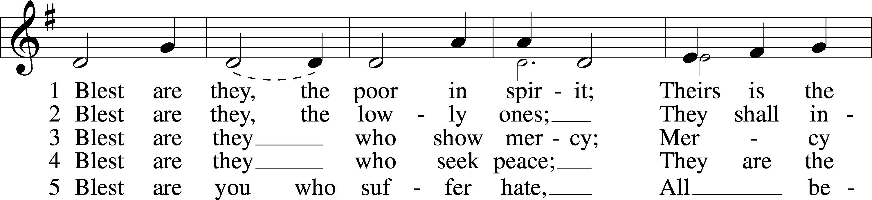
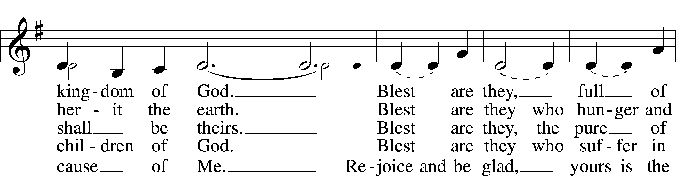
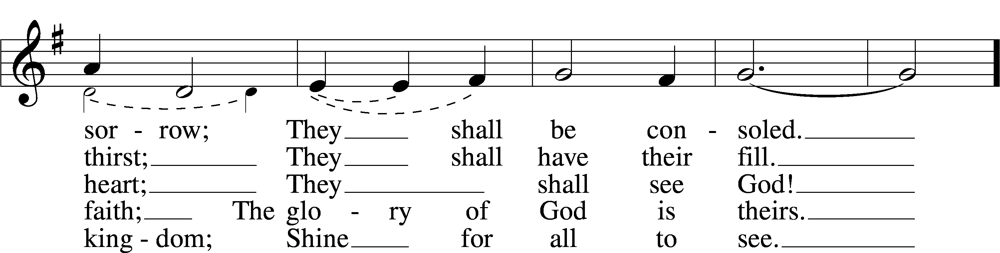
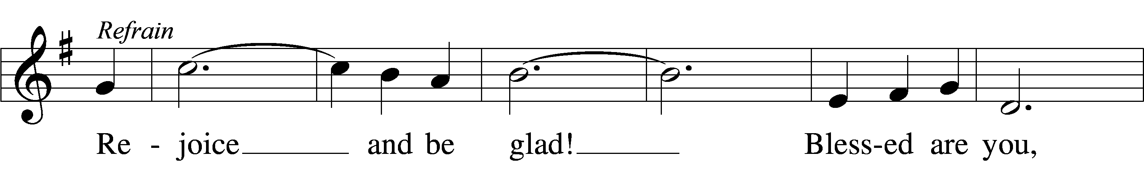
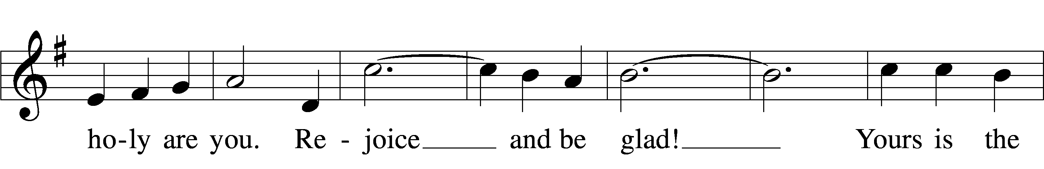
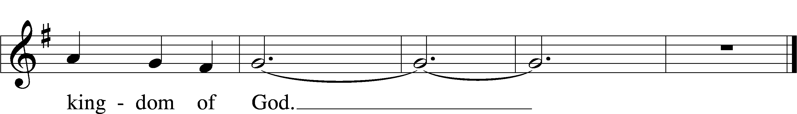
Text and tune: David Haas, 1957
Text and tune: © 1985 GIA Publications, Inc. Used by permission: LSB Hymn License no. 130404864

982 Blest Are They
Text and tune: David Haas, 1957
Text and tune: © 1985 GIA Publications, Inc. Used by permission: LSB Hymn License no. 130404864

